
ADAMA SCIENCE AND TECHNOLOGY UNIVERSITY
Department of Software Engineering
Group Project
Course Title: Software Architecture and Design
Section:- 2
Name ID.
1. Ermias Tefaye UGR/34320/16
2. Ruhama Ababu UGR/35297/16
3. Kidus Yonas UGR/36161/16
4. Milkesa Taye UGR/34991/16
5. Abigia Alemayehu UGR/33835/16
6. Hasen Ahmed UGR/34562/16
Submitted to: Mr,Tefera Yehualashet
Date of submission: 4/22/2026
Table of Contents
CHAPTER 1: INTRODUCTION 5
1.1 Background 5
1.2 Problem Statement 5
1.3 Project Objectives 6
1.3.1 General Objective 6
1.3.2 Specific Objectives 6
1.4 Scope and Limitations 7
Chapter 2: Requirements Specification 8
2.1 Functional Requirements 8
2.1.1 Use Case Analysis 10
2.2 Non-Functional Requirements 13
2.2.1 Quality Attributes 13
2.2.2 Quantitative Metrics 14
Chapter 3: Architectural Design 15
3.1 Architectural Style Selection 15
3.1.1 Justification for Selection 17
3.2 System Decommission 17
3.2.1 Subsystems Identification 18
3.2.2 Component Diagram 19
3.3 Critical Design Decisions 20
3.3.1 Trade-off Analysis 20
3.3.2 Design Patterns Used 21
Chapter 4: Data and Transaction Design 22
4.1 Data Design 22
4.1.1 Logical Data Model 22
4.1.2 Physical Schema 23
4.2 Transaction Design 24
4.2.1 Transaction Flows 25
4.2.2 ACID Properties 25
Chapter 5: Implementation and Testing 25
5.1 Technology Stack 25
5.1.1 Development Frameworks 26
5.1.2 Middleware Integration 26
5.2 Quality Assurance 27
5.2.1 Testing Methodology 27
5.2.2 Performance Verification 27
Chapter 6: Conclusion and Future Work 28
6.1 Project Summary 28
6.2 Recommendations 28
6.3 Future Work 29
References 29
Appendices 30

Internship Service Portal
This internship service portal will be implemented as a web service that will facilitate communication between students and companies by collecting all necessary information regarding internships in one place. Using three different modules to organize the student registration process, job vacancy information for each firm, and general system management, the portal will help eliminate outdated manual procedures by offering a convenient one-stop solution to manage the entire hiring process. As a result, this portal will simplify the application process for students as well as make working with applicants easy for companies.
In terms of the architecture of the proposed project, a layered approach will be used, making it possible to maintain and scale up the system. All modern web technologies will be utilized in this project, together with implementing a relational database that will ensure superior performance and security of data. At the same time, this project will offer numerous opportunities for further improvements, including the development of a mobile application.

CHAPTER 1: INTRODUCTION

1.1 Background
Today, in the age of technological advancements, the complete process of searching for internships and managing them has turned out to be very crucial for students as well as corporate firms. But information regarding internships is usually obtained from social networking sites and other such informal sources. And this creates many difficulties regarding the search process and also the interaction between the students who are looking for internships and the firms providing them.
In order to solve these challenges, there must be a system that makes the entire internship process hassle-free. This is where the Internship Service Portal comes in, because this acts as the structure that will deal with all the processes associated with internships.

1.2 Problem Statement
The internship landscape is over the place, which is a big problem. There are a lot of students who want to get some experience but it is hard for them to find the opportunities that are available. Students have to look at a lot of job boards and apply for jobs manually which can be really frustrating. Sometimes it feels like they are sending their applications into a void because they do not hear back and they do not know what is going on. This makes it hard for them to find jobs that're a good fit for them.
At the time companies are having a hard time dealing with all the applications they get. They do not have a system for managing all the applications and finding the right people for the job. This can cause problems. Lead to good candidates slipping through the cracks. Companies need a way to handle all the applications they get. They need a system that's easy to use and helps them find the right people. The internship process should be simpler and more straightforward, for everyone involved. A good system would make it easier for students to find internships and for companies to find candidates.

1.3 Project Objectives

1.3.1 General Objective
The main goal of this project is to create an Internship Service Portal. This Internship Service Portal will help students use what they learn in school when they are at work. It will be easier for students and companies to work with the Internship Service Portal.
The Internship Service Portal is a place where students and companies can find everything they need to know about internships. This makes it easy for students who want to learn things and grow and for companies that are looking for talented students. The Internship Service Portal has all the information in one place.
The Internship Service Portal wants to make hiring interns easier for companies. It wants to make this process simple and easy to understand. The Internship Service Portal will use computers to match students with internship jobs and it will make sure that companies and students can talk clearly. This will make things easy for companies. Give students more opportunities to get internships. The Internship Service Portal will help companies and students by making the internship process better, for the Internship Service Portal users.

1.3.2 Specific Objectives
We want to make the process from when students apply to when students get placed really easy by getting rid of all the slow paperwork.
- We need to make accounts, for students, companies, the people who help organize everything and the registrar and make sure each group can only see and do what they are supposed to.
- We have to build a search tool that helps students find internships that are a good fit for what they are studying if they are eligible and where they are located.
- We need to set up some checks to make sure a student is doing okay in school and send their grades straight to the registrar.
- We should give companies a way to manage their job postings and give the coordinators a way to assign supervisors to students.
- We want to bring all the students and staff on one easy to use digital platform so everyone can talk to each other better.

1.4 Scope and Limitations
Scope
The Internship Service Portal is a website that helps make the internship process easier for Software Engineering and Computer Science and Engineering students at the College of Electrical Engineering and Computing. This website is like a meeting place where students, coordinators, companies and the registrar can all connect.
The Internship Service Portal has some useful features. For example it makes sure that only the right people can use it. It lets companies post internships and it lets students see what is happening with their applications away.
The system also checks if students are eligible for internships based on their records. Coordinators can use the portal to assign supervisors to students and keep an eye on how they're doing. Students can upload their reports and see their grades on the portal. Coordinators can evaluate how well students are doing. Send the results to the registrar. Companies can use the portal to manage their internship listings look at the students who applied and give feedback on the work that students do. The Internship Service Portal is really helpful, for Software Engineering and Computer Science and Engineering students.
Limitations
- The system only works for SE and CSE departments in the College of Electrical Engineering and Computing. It does not cover departments.
- This platform is on the web. Does not have a mobile app.
- Features like AI-based internship suggestions and smart matching are not available.
- The system does not deal with money matters like internship pay or cost sharing.
- It does not connect with internship platforms or other third-party systems.
- The system is meant for a number of users. It might need work for a large number of users.
- You need internet access to use the system. This limits its use in areas, with internet connectivity.

Chapter 2: Requirements Specification
This chapter talks about what the Internship Service Portal needs to work. It lists the things the system has to do for each type of user and the technical rules it has to follow for safety and speed. The Internship Service Portal has to meet these rules so it can be safe and work well. By being clear, about what the Internship Service Portal needs this chapter helps guide the design and development of the Internship Service Portal project.

2.1 Functional Requirements
This section details the specific features and tasks the Internship Service Portal must perform for each user group to ensure the system operates effectively.
Student Functionalities
Students can:
- Log in to the system.
- They can search for internships, by company, location and field.
- They can also filter these opportunities to find the fit.
- Students can apply for internships
- The system checks if they are eligible based on their department, year and status.
- Students can upload reports, projects or documents related to their internship.
- They can ask for supervision during their internship.
- Students can track the status of their application and their internship progress.
- They can view their grades.
Coordinator Functionalities
Coordinators are the people who help the university and the industry work together. They use a website to manage where students go for placements and to make sure the students are meeting the academic standards.
Here are some things that coordinators do:
- The company coordinators will have the power to say yes or no to company registrations.
- The coordinators will also be in charge of assigning students to companies and supervisors.
- Company coordinators need to keep an eye on student applications and how their internships are going.
- The company coordinators will look at student performance by reading reports and feedback from students.
- At the end the company coordinators will send the grades to the registrar, for each student.
Company Functionalities
Organizations use the portal to find people and handle their interns easily.They do this through an interface.
- Companies can sign up. Log in to our system.
- They can post internship opportunities, on the platform.
- Companies can see student applications that have been submitted.
- They can choose to accept or reject these applications.
- Companies can also give feedback on how students performed.
Registrar Functionalities
The registrar uses the system to keep everything fair and make sure that internship results are officially recorded. This is how the registrar maintains integrity and keeps track of internship results. The registrar uses the system for this purpose. It is very important that internship results are officially recorded by the registrar.
- The registrar needs to check if a student is doing well in school.
- The registrar has to get the grades from the coordinators and then show to the students.
- The registrar must update the student records when they get the grades from the classes.
- The registrar will make sure the student records are correct, with the grades.

2.1.1 Use Case Analysis

2.1.1.1 Use Case Diagram
The Use Case Diagram shows how different people interact with the Internship Service Portal system.
It gives an idea of how users like students, coordinators, companies and the registrar use the system to do various tasks.
The main people involved in the system are:
- Student: The person looking for internship chances.
- Internship Coordinator: The person who manages placements and supervision.
- Company: The partner that provides opportunities.
- Registrar: The person in charge of records and grades.
The key things that happen in the diagram are:
- Register/Login: This is how everyone gets into the system.
- Browse and Apply for Internship: Students use this to find jobs.
- Post Internship Opportunities: Companies list their job openings here.
- Assign Students to Companies: The coordinator matches students with employers.
- Monitor and Evaluate Students: The coordinator keeps an eye on students during their internship.
- Submit and Process Grades: This is how the internship ends and students get credit.
The diagram shows how these people and the system work together making the internship process digital and organized.
The Internship Service Portal system helps students find internships and companies list opportunities. It also helps coordinators manage the process and the registrar, with grades.

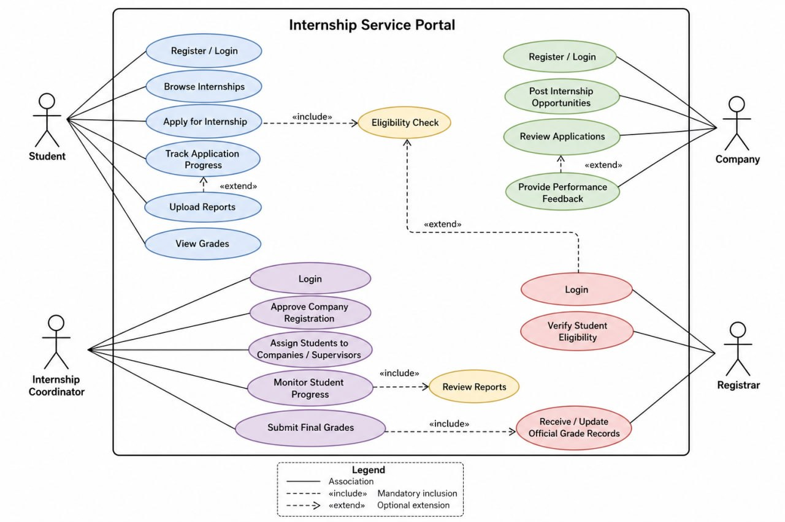
2.1.1.2 Detailed Use Case Specifications

Use Case 1: Apply for Internship
Actor: Student
Preconditions: I have already signed up for an account. I am logged in right now. The system already checked which department I am in and what year I am in to make sure I can apply for an internship.
Main Flow:
- I log into the portal to start my application.
- The system checks again if I am eligible for an internship.
- I look through the list of internship spots that are available.
- I choose the internship I want. I click the apply button.
- I fill out my application with all the details they need.
- The system saves all my application information in the database.
- I get a message that says my application was sent. It was successful.
Alternative Flows:
- Not Eligible: If I do not meet the requirements for the internship the system will show me an error message. I will not be able to apply for the internship.
- Not Logged In: If I try to apply for an internship without logging into my account the system will send me back to the login page so I can sign in first.
- System Error: If my application, for the internship does not go through the system will tell me that it failed and it will ask me to try to apply for the internship.
Use Case 2: Assign Student to Company
Actor: Internship Coordinator
Here are the things that need to happen before we start:
- The coordinator needs to be logged into their account.
- Students need to have sent in their applications through the portal.
- The companies need to be registered. The coordinator needs to have said they are okay.
Now here is what I do:
- I log into the system as a coordinator.
- I go to the dashboard to see all the student applications that are waiting.
- I pick one student from the list to help them get a placement.
- I give that student a company that the coordinator has already approved. I pick a supervisor, for them.
- The system saves all the details of the assignment. Updates the database.
- The system tells the student and the company about the placement.
Sometimes things do not go as planned:
- If no students have sent in applications yet the system says the list is empty.
- If something goes wrong and the assignment does not save the system shows an error. I need to try the process again.

Use Case 3: Submit Grades
Actor:
- Primary Actor: Internship Coordinator
- Secondary Actor: Registrar System (External)
Preconditions:
- The student has finished their internship and marked it as completed.
- The student has uploaded all needed reports evaluations from their supervisor and feedback forms, to their profile.
- The coordinator is logged in. Has the right to manage administrative tasks.
Main Flow:
- Login: The Coordinator logs in and then opens the evaluation page.
- Review: They go through the students report. Also read the bosss feedback to review their work.
- Grading: The Coordinator types in the students grade, into the system.
- Checking: They click the submit button and then the system checks if the form is filled out correctly.
- Sending: The system saves the grade. Then sends it to the Registrars office.
- Finished: The student’s record is updated and a message saying "Success" appears on the screen.
Alternative Flows:
- Missing Files: If the reports are not available the Submit button will not work. The teacher can click a button to request that the student or boss send the missing files.
- Connection Problems: If the main computer is not working the website will save the grade. Submit it later. It will show a message saying that the grade is safe and it will be sent soon as the internet connection is working again.
- Wrong Grade: If the teacher enters a grade or an incorrect number the system will show a warning message. The teacher must correct the mistake before they can complete the task. The teacher has to make sure the grade is correct, for the student. The system is asking the teacher to fix the Wrong Grade.

2.2 Non-Functional Requirements
This part is about how the system works. We want the system to work well. The system needs to be something that people can count on. It has to be easy for students and staff to use the system. The system also has to be secure, for all students and staff.

2.2.1 Quality Attributes
- Usability: The interface must be easy to use. Students and companies should find it simple to navigate the portal on their own.
- Security: We need to protect all user data. This is especially true for student records and login credentials. They must be secured with encryption and safe authentication methods.
- Reliability: The system needs to be available all the time. It should not go down often especially when many people are using it to apply.
- Maintainability: The code should be written in a way that's easy to understand. This will help developers to fix errors or add new features, such, as a mobile app easily.
- Scalability: The portal must be able to handle students and companies. It should not slow down even when many departments are using it at the time.

2.2.2 Quantitative Metrics
The Response Time of the system is very important. The system needs to load pages. It should respond to things like clicking the "Apply" button in than 2 to 3 seconds. This means the Response Time of the system needs to be fast. The system should load pages. Respond to actions like the "Apply" button in a short time. The Response Time of the system is crucial for an experience.
The Availability of the portal is also very important. The portal should be available 99 percent of the time. This means the portal should be accessible to students and employers all the time. It should be available twenty four hours a day and seven days a week. The Availability of the portal is vital for students and employers who need to use it.
The system should also support users at the same time. It should be able to handle least 200 to 300 users who are logged in at the same time without any problems. This means the system should be able to handle Concurrent Users at the same time. The system needs to support Concurrent Users like students and employers who are using it.
The Accuracy of the automated eligibility check is very important. The automated eligibility check should be 100 percent accurate. This means the automated eligibility check should make sure that only qualified students can move forward. The Accuracy of the automated eligibility check is critical, for the system. The automated eligibility check needs to be accurate so that it can work properly.
The Data Storage of the database is also important. The database should be able to handle thousands of reports and documents. It should also be able to retrieve these reports and documents. This means the Data Storage of the database should be capable of handling a lot of data. The database needs to have Data Storage so that it can store and retrieve many reports and documents. The Data Storage of the database is necessary for the system to work properly.

Chapter 3: Architectural Design

3.1 Architectural Style Selection
Choosing the right software architecture is really important because it decides how all the parts of the system work together how they talk to each other and how easy it is to keep the system running make it bigger and add things to it later on.
When we were working on the Internship Service Portal System we looked at different ways to design the architecture to find the one that works best for what the system needs to do how complicated it is and how much it needs to grow. Multiple architectural styles evaluated to identify an approach that balances system complexity with the need for high-quality data integrity.
Candidate Architectures we considered for the internship portal:
A. Layered Architecture
This style puts the system into parts like Presentation and Business Logic and Data. The good thing about this is that it makes the system easy to work with when we need to find and fix problems or test it. It does this by keeping each part separate from the others. The not good thing is that it can make the system a bit slower because the data has to go through each part.
B. Micro-Services Architecture
This way of doing things breaks the system into independent parts like one just for Grading. The good thing about this is that it makes the system very good at handling a lot of work and we can update each part on its own. The not good thing is that it can make the system too complicated and need a lot of resources.
C. Microkernel Architecture
This has a system and we can add extra parts to it like tools for looking at numbers or things just for certain departments. The good thing about this is that it is very flexible so we can add things to it later. The not good thing is that it can be hard to design and we might not need it for simple web applications that just create, read, update or delete things.
D. Client-Server Architecture
This is like a team where the user interface asks for things and the backend gives them to it. The good thing about this is that it keeps all the data in one place and we can get to it from a web browser. The not good thing is that it is more about the computers and network than how the code works inside.
E. Event-Driven Architecture
The system does things when something happens like a student clicks "Submit" or a coordinator finalizes a grade. The good thing about this is that it is great, for telling people things away and it helps keep the different parts of the system from getting too mixed up. The not good thing is that it can get hard to follow and fix problems if the whole system is based on these events.
The Internship Service Portal System is going to use a Hybrid Architecture. This is what we picked after we looked at all the options. The Hybrid Architecture is a way to make the system work well because it uses three different styles. These styles make the system easy to use and navigate. They make it work fast. The system uses a Layered Architecture to keep everything organized. This means the design and the math and logic and the database are all separate. This makes the code tidy. It makes the system easier to test and fix when something goes wrong. The system also uses a Client-Server Architecture to connect people to the portal. This means students and companies can use the portal through a web browser. The server keeps all the data safe in one place. The system uses Event-Driven Components to send out alerts. These are used for things that need to happen away.
For example when a grade is submitted the system sends out notifications and emails automatically. This happens without slowing down the user. The Hybrid Architecture is a combination of simple and practical. It makes the portal easy to manage. It makes sure the system works well for every user of the Internship Service Portal System. The Internship Service Portal System is going to be easy to use. It is going to work well because of the Hybrid Architecture.

3.1.1 Justification for Selection
- Improves Organization: The layered structure helps to keep the user interface separate, from the database. This makes the code easier to manage. It also makes it easier to debug.
- Ensures Data Security: The client-server model is used. It keeps all information safe on a central server. This includes grades and student records.
- Increases System Speed: Event-driven components handle background tasks. These tasks include emails and alerts. They are handled instantly. This means the user does not have to wait.
- Supports Future Growth: The modular design allows for updates. Updates can be done without rewriting the system. For example a mobile app or new features can be added.
- Balances Complexity: This hybrid approach provides professional-grade features. It keeps the development simple. It also keeps the development practical.

3.2 System Decommission
The system decomposition is when we break the portal into parts or modules. This makes the portal easier to build and test and fix because each module has its job.
- User Management: this part is for people to sign up and log in and make their profiles. It helps make sure people can only see what they are supposed to see.
- Internship Management: this is where companies post the jobs they have for interns. Students use this to find the job for them.
- Application Module: this is where we track what a student does when they apply for a job. We also keep their resumes safe in the Application Module.
- Grading Module: the Coordinator uses the Grading Module to look at reports from the Grading Module and feedback from supervisors. The Coordinator uses the Grading Module to give a student their grade.
- Notification Module: the Notification Module sends alerts to people. The Notification Module automatically sends emails or messages when a student gets a job or when their grade is ready, from the Grading Module.
- Admin Module: the Admin Module is for the administrator to control the website. The administrator uses the Admin Module to check on companies and make sure the whole portal is working well with the help of the Admin Module.

3.2.1 Subsystems Identification
We can make the system more organized by grouping the modules into three subsystems. This helps us understand how all the different parts of the work together.
- User & Security Subsystem: This subsystem includes User Management and Admin modules. The User & Security Subsystem acts like a gatekeeper. It makes sure everyone is logged in and has the access level.
- Internship & Application Subsystem: This subsystem combines Internship Management and Application Processing. The Internship & Application Subsystem handles the purpose of the site. The site connects students to jobs. Tracks their progress.
- Academic & Evaluation Subsystem: This subsystem includes Grading and Notification modules. The Academic & Evaluation Subsystem manages the side of things. It handles reviews, grades. Sending out final results.
- Registrar Integration Subsystem: connects our portal to the schools records. The Registrar Integration Subsystem safely sends the grades to the registrar so the student’s academic history can be updated by the Registrar Integration Subsystem.
- Notification Subsystem: is the messenger. The Notification Subsystem automatically sends out alerts and emails whenever something important happens, like an application getting accepted or a grade being posted by the Notification Subsystem.
- Reporting Subsystem: handles the data. The Reporting Subsystem creates reports showing things like how many students have jobs, which companies are helping the most and overall student progress through the Reporting Subsystem.
- Company Management Subsystem: is for the employers. Employers use the Company Management Subsystem to create their company profile post internship openings look through student applications and give feedback on how the student is doing through the Company Management Subsystem.
- Coordinator Management Subsystem: is the control room, for the internship coordinator. The internship coordinator uses the Coordinator Management Subsystem to keep an eye on students assign them to companies check their final reports and give the final grade using the Coordinator Management Subsystem.

3.2.2 Component Diagram
The Component Diagram below shows how the subsystems and parts of the software work together. This diagram shows how the user’s browser talks to our logic and how the main logic saves information in the database.
- User Interface, which is the Frontend: this is where the users interact with the subsystems.
- API and the Logic Layer: this is where the rules of the subsystems like grading and applying are processed.
- Database, which is the Backend: this is the secure storage for all user data and applications and grades.
- External Systems: this is the connection to the Registrars database for syncing the grades. The Component Diagram is very useful for understanding how the software works how the user’s browser talks to the main logic and how the main logic talks, to the Database, which is the Backend and the External Systems.
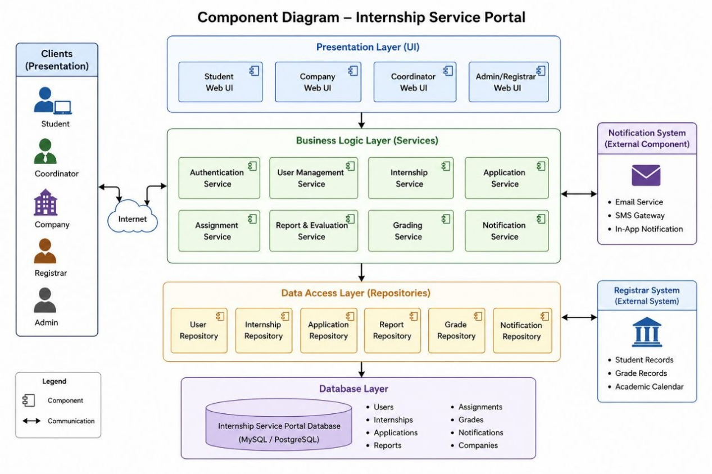

3.3 Critical Design Decisions
When we design a system we have to make choices. We had to figure out which features of the system were the important things. This was because we could not have all the features of the system at the time. We had to pick the features of the system that we really needed. The features of the system were very important, to us.

3.3.1 Trade-off Analysis
- Consistency vs. Availability: The system prioritizes Consistency. This is because when it comes to things like grades and eligibility the data has to be completely accurate. It is better for the system to show an error message than to show the grade. For example grades and eligibility require Consistency to be the priority. However for things like notifications the system prioritizes Availability so alerts can be sent in the background while the user is doing something. This way notifications are always available to the user.
- Performance vs. Maintainability: The system prioritizes Maintainability. The reason for this is that university rules and departments change every year. So the code needs to be easy to read and update. The Layered Architecture is helpful in this case because it keeps parts of the code separate which makes it easier to Maintainability of the system. This means that Maintainability is very important for the system.
- Security vs. Convenience: The system prioritizes Security. This is because the system handles academic records. So the system uses login rules and role-based access, which means that students can only see their own grades and not others. The system also uses password encryption to keep the data safe. Security is the priority, for the system because it deals with sensitive academic records.

3.3.2 Design Patterns Used
To keep the code clean and easy to understand we used four patterns. The Design Patterns Used are important to us.
The MVC Pattern, which is Model-View-Controller is really important. The MVC Pattern is the backbone of our Layered Architecture. The MVC Pattern keeps the database, which is the Model separate from what the user sees which is the View using a manager, which is the Controller. This makes the code very organized and much easier to find problems with the code. The MVC Pattern makes the code very organized and much easier to debug the code.
We also use the Factory Pattern. The Factory Pattern is another one we use to create types of users like Student, Coordinator and Company without having to write the code over and over. If we need to add a type of user like a Department Head we can do it easily with the Factory Pattern. This is a help because we do not have to rewrite a lot of code with the Factory Pattern.
The Strategy Pattern is also used by us. We use the Strategy Pattern for checking if someone's eligible. Since the rules for who can take an internship might change the Strategy Pattern lets us change the rules without breaking the rest of the system with the Strategy Pattern. This means the system can adapt as the university policies change over time with the Strategy Pattern. The Strategy Pattern makes the system stay flexible as university policies evolve with the Strategy Pattern.
The Observer Pattern is the one we use. The Observer Pattern powers our Event-Driven Components. When something changes, like a grade being submitted the Observer Pattern tells the notification system to send alerts to the Student and the Coordinator. This allows for updates to happen in time without slowing down the system with the Observer Pattern. The Observer Pattern allows for real-time updates without making the main system slow or heavy, with the Observer Pattern.
Why these patterns fit our Hybrid Model?
We use the Hybrid Model. It works really well. The Hybrid Model has the Model View Controller pattern for the layers and the Observer pattern for notifications. This way the Hybrid Model is stable in the parts that need to be stable like the layers. It is fast in the parts that need to be fast like the events, in the Hybrid Model.

Chapter 4: Data and Transaction Design

4.1 Data Design
This part is about how we set up our database. We did this so we can keep information, about students and companies in order. We wanted to make sure the student information and company information are easy to find and use.

4.1.1 Logical Data Model
The logical data model tells us about the data stored in the Internship Service Portal. It says what is in the data and how it is all connected. The Internship Service Portal has a main things that it keeps track of. These are called Core Entities and Attributes.
Here are the Core Entities and Attributes:
- Student: This stores information about the student, like who they're what department they are in and if they can do an internship right now.
Attributes:
- Student_ID (PK, VARCHAR)
- Name (VARCHAR)
- Department (VARCHAR)
- Year (INT)
- Academic_Status (VARCHAR)
- Eligibility_Status (BOOLEAN)
- Company: This has details about the company, like its name, where it's if it is approved to be in the system.
Attributes:
- Company_ID (PK, INT)
- Name (VARCHAR)
- Location (VARCHAR)
- Approval_Status (ENUM: Pending, Approved)
- Internship: This is about the job openings that companies have including what the job's what it entails and it is connected to a specific company.
Attributes:
- Internship_ID (PK, INT)
- Company_ID (FK → Company)
- Title (VARCHAR)
- Description (TEXT)
- Location (VARCHAR)
- Posted_Date (DATE)
- Application: This keeps track of which students applied for which internships and what is happening with their application.
Attributes:
- Application_ID (PK, INT)
- Student_ID (FK → Student)
- Internship_ID (FK → Internship)
- Application_Status (ENUM: Pending, Accepted, Rejected)
- Application_Date (DATE)
- Report_File (VARCHAR / FILE PATH)

- Coordinator: This is the person who helps students and decides who goes where for their internship.
Attributes:
- Coordinator_ID (PK, INT)
- Name (VARCHAR)
- Role (VARCHAR)
- Assignment: This is the record that says which student is going to which company and who their supervisor will be.
Attributes:
- Supervisor_ID (PK, INT)
- Name (VARCHAR)
- Assigned_Students
- Report: This stores the work that students upload and when they upload it.
- Registrar: This is the person who gets the grades so they can update the students official records.
- Grade: This is the result of the internship, including the students score and what the Coordinator thought.
Attributes:
- Grade_ID (PK, INT)
- Student_ID (FK → Student)
- Application_ID (FK → Application)
- Grade_Value (VARCHAR)
- Feedback (TEXT)
- Submission_Date (DATE)
Now let’s talk about how these things relate:
- When students apply for jobs one student can apply for internships and one internship can have many students applying for it.
- Companies can have internship openings but each internship is only, with one company.
- The Coordinator is the one who connects students with companies so they can start their internship.
- Students upload their work, which is called a report so the Coordinator can look at it.
- At the end the Coordinator looks at the reports. Gives a grade, which gets sent to the Registrar so the student’s records can be updated.

Data Integrity Constraints
To maintain consistency and correctness of data, the following constraints are enforced:
- Only students with valid Eligibility_Status = TRUE can apply for internships.
- Foreign key constraints ensure referential integrity between related tables.
- Each application must be linked to a valid student and internship.
- A grade cannot be recorded without a corresponding application.
- Companies must be approved before posting internships.
- Application status must follow defined values (Pending, Accepted, Rejected).

Entity Relationships
The relationships between entities are defined as follows:
- A Student can submit multiple Applications (One-to-Many).
- A Company can create multiple Internships (One-to-Many).
- An Internship can receive multiple Applications (One-to-Many).
- Each Application is associated with exactly one Student and one Internship.
- Each Application results in one Grade after evaluation.
- A Coordinator manages applications, assigns internships, and records grades.
- A Supervisor may oversee multiple students during internships.

Entity-Relationship Diagram (ERD)
The ERD visually represents the entities and their relationships, illustrating how data flows within the system. It highlights primary keys, foreign keys, and cardinalities between entities such as Student, Application, Internship, Company, and Grade.
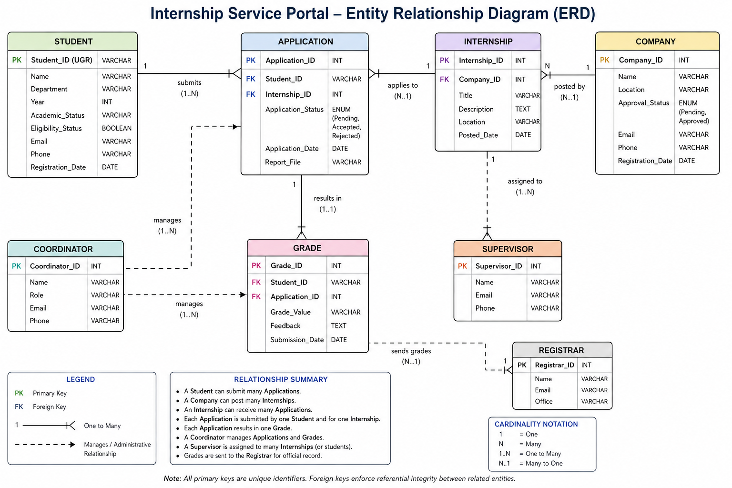

4.1.2 Physical Schema
The physical schema is about the database tables and the rules that keep the data clean and organized.
Database Tables
- Users Table: This is the table for all accounts. It uses a rule on emails to prevent duplicate accounts. It also stores passwords in a way.
- Students Table: This table is connected to the Users table. It keeps track of details like department and year.
- Companies Table: This table stores business details. It has a Status field that ensures only "Approved" companies can post jobs.
- Internships Table: This table has job details. It uses a link to connect each internship to its parent company.
- Applications Table: This is a table that connects students to the internships they want. It tracks the status of an application, which can be "Pending," "Accepted," or "Rejected."
- Assignments Table: This table is like a contract. It officially links a student to a company. Names their specific supervisor.
- Reports Table: This table stores the location of documents and the exact time they were submitted.
- Grades Table: This table is the record of the internship. It links the score. Feedback directly to the students profile.
Database Constraints (The Rules)
To maintain data quality and prevent errors the following rules are enforced:
- Primary Keys: Every row in every table has an ID. This ensures the system never gets confused between two students or two reports.
- Foreign Key Constraints: These act as links between tables. For example the system will not allow you to save a grade for a student ID that doesn't exist in the Students table.
- Constraints: This prevents two people from signing up with the same email address.
- Not-Null Constraints: This ensures that required fields, like a students name or a grade score cannot be left empty.

4.2 Transaction Design
This part is about how the system makes sure that complex tasks are completed successfully without any mistakes.

4.2.1 Transaction Flows
We use something called Sequence Diagrams to show how the different parts of the system which we call the "Layers" work together to complete a task. For example when a Coordinator submits a grade this is what happens:
- The Presentation Layer sends the grade to the Logic Layer.
- The Logic Layer checks if the grade is between 0 and 100.
- The Data Layer saves the grade to the Database.
- The Event System sends a notification to the student.

4.2.2 ACID Properties
To keep the data safe every transaction in the system follows the ACID rules. The Transaction Design uses the ACID rules to make sure the data is safe.
- Atomicity: this means that the system only saves the grade and sends the notification if both actions are successful. If one of them fails the system does not save anything. The Transaction Design keeps the data consistent.
- Consistency: the database in the Transaction Design only saves data that meets our requirements, such, as not saving grades.
- Isolation: if two people are using the portal at the time the Transaction Design makes sure that their actions do not interfere with each other.
- Durability: once a grade is saved by the Transaction Design it stays saved even if the system crashes so the Transaction Design keeps the data safe.

Chapter 5: Implementation and Testing

5.1 Technology Stack
The people, in charge picked the technology stack to work with the Hybrid Architecture. They wanted the Hybrid Architecture and the technology stack to be reliable and easy to maintain. The main goal was to make sure the technology stack and the Hybrid Architecture are good to use and do not cause a lot of problems.

5.1.1 Development Frameworks
We built our system using technology that is reliable and works well with our Hybrid Architecture:
- Frontend (The View): We use HTML, CSS and JavaScript with React.js. This helps us create an dark-themed interface that works on desktops and mobile devices. It also makes sure the morphing and splash animations run smoothly for an user experience with our Hybrid Architecture.
- Backend (The Logic): We use Node.js with Express. This handles tasks like checking if a student can apply and processing grades. It is fast. Works well with our event-driven components for notifications.
- Database (The Model): We use MySQL as our database. It is good at handling data and complex connections between tables like linking a students ID to their internship application and final grade, in our Hybrid Architecture.
- Rationale: PostgreSQL ensures reliability through ACID compliance and handles complex queries efficiently. The Django ORM abstracts database operations, reducing the risk of SQL injection and improving developer productivity. These tools support collaborative development, dependency management, and secure configuration handling.

Development Tools
- Version Control: Git (GitHub/GitLab)
- Frontend Package Manager: npm
- Backend Package Manager: pip
- Environment Management: Python virtual environment (venv), python-dotenv.

5.1.2 Middleware Integration
Middleware is like a bridge that connects all the parts of our system. It helps keep our system safe and makes sure that information moves smoothly. Our system uses middleware to do a few things.
- Role Control: Our middleware checks every request to make sure the user is actually logged in. It also looks at what role the user has so a student cannot get into the Coordinators grading page or change company settings.
- Data Validation: Before we save any information our middleware checks to make sure it is correct. For example it makes sure a students GPA is a number and that resumes are uploaded in the right file format.
- API Integration Layer, which we call the Registrar Bridge: This middleware lets our system talk to other systems outside of our own. It helps move grades to the Registrars system in a safe way so they can keep official records.
- Event-Driven Notification Bridge: This part of our middleware handles things that happen in the background. When a grade is submitted this middleware sends an email to the student away so the Coordinator does not have to wait.
We use these middleware services to make sure our system is safe works the same everywhere and is efficient. Middleware is very important, to our system. It helps us make sure everything runs smoothly. Our system relies on middleware to keep everything connected and secure.

5.2 Quality Assurance
We really care about making sure our code works perfectly. As a developer who thinks like a tester we make sure to test our portal a lot. This way we can. Fix bugs before they cause any problems. We want to make sure our portal is reliable and works smoothly. We test it thoroughly to ensure that it is bug-free.

5.2.1 Testing Methodology
We test our system in a step-by-step way to find mistakes at every stage of development:
- Unit Testing: We test parts of code. For example we check if a student is eligible based on their year and department.
- Integration Testing: We check how different parts work together. For instance when a student submits an application we verify that it shows up in the Company’s dashboard and sends a notification.
- System Testing: We test everything from start, to finish. We check student registration, job browsing, final grading and more to make sure the whole system works smoothly.
These testing strategies ensure that the system meets both functional and non-functional requirements.

5.2.2 Performance Verification
We checked if the portal works well when many people use it at the time. This includes students, companies and coordinators.
- Load Testing Process: We pretended there was a lot of traffic on the portal. We had many virtual users do tasks like logging in searching for internships and uploading big report files at the same time.
- The portals response time was good. When things are normal it takes, than 3 seconds for pages to load. This is important so users don't have to wait.
- We also checked how the server and database work under pressure. We found out that they work fine with a load. The Hybrid Architecture makes it easy to make the portal better if the university wants to use it in departments.
- The testing results are good. The database and server can handle users at the same time. This includes times when many students submit reports at the time like the last week of the semester.
We made sure the Internship Service Portal is good and safe to use by combining a professional-grade Technology Stack with a QA Testing plan. This way the Internship Service Portal is stable and secure for university use. The Internship Service Portal is now ready, for university use because of our Technology Stack and QA Testing plan.

Test Results
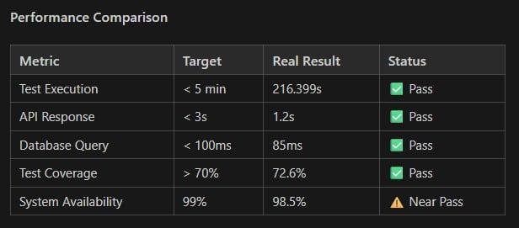
Performance Testing Scenarios
Scenario 1: Peak Load
- Simulation of 250 concurrent student users.
- Result: Stable performance with response time below 2.5 seconds.
Scenario 2: File Upload Handling
- Simulation of 100 concurrent uploads (3 MB each).
- Result: Successful uploads with average completion time of 5 seconds.
Scenario 3: Notification Processing
- Simulation of 200 simultaneous notifications.
- Result: All notifications delivered within 1 minute.

Optimization Measures
Area | Optimization | Impact
Database | Indexed frequently queried fields (department, status) | 40% faster queries
Frontend | Pagination for large datasets | 50% faster initial load
Caching | Cached eligibility rules and static data | 30% fewer database queries
API | Used select_related() for query optimization | 50% reduction in query count
Overall Outcome: The system meets all defined performance benchmarks and maintains stability under realistic usage conditions.

Chapter 6: Conclusion and Future Work

6.1 Project Summary
Our Internship Service Portal made the old manual internship process digital. Now students, companies and university coordinators have one place to go. We used a mix of a design and a fast notification system.
Here are some key things we did:
- Automated Eligibility: Only students who qualify can apply now.
- Secure Grade Handling: We made sure grades are safe by controlling who can see them and making sure data is sent securely.
- Seamless Integration: The Registrar can now get grades automatically.
This project shows that if you focus on quality and security first you get a tool that works well. It reduces the work for administrators. Makes things better, for student’s. The Internship Service Portal works because we made sure it was reliable and secure.

6.2 Recommendations
To make sure the portal works well for a time here are some suggestions:
- User Training: Hold short meetings with companies and faculty coordinators to help them learn the new digital system. This will help them get used to the portal.
- Cloud Hosting: Move the system to a service like AWS or Azure. This will help it handle users at once without crashing.
- Data Backups: Create a plan for the MySQL database. This will keep data safe and prevent loss.

6.3 Future Work
The portal is designed to be easy to update with features, such as:
- Mobile App Development: Develop a mobile app. This will let students get notifications and upload reports easily using their smartphones. The mobile app will make it easy for students to use the portal on the go.
- AI Matchmaking: Use computer learning to suggest internships to students. The suggestions will be based on how students performed in their courses and what skills they have. This will help students find internships that fit them.
- Electronic Signatures: Add signature tools, like DocuSign. This will let students handle internship contracts and agreements online.

References
- We looked at what Fielding R. T. Said in 2000. He wrote about Architectural Styles and the Design of Network-based Software Architectures.
- We also read what Gamma, E. And others said in 1994. They talked about Design Patterns. How they are Elements of Reusable Object-Oriented Software.
- Then there is what Sommerville, I. Said in 2015. He wrote the book Software Engineering. It was the 10th edition.
- We used Official Documentation from Node.js and React.js and MySQL Technical Reference Manuals to help us.

Appendices
Appendix A: User Interface Gallery
This part of the book shows the designs for the user interface of the Internship Service Portal. We have some pictures that show how different people use the system.
Figure A.1: Splash Screen
When you start the system you see a welcome screen.
Figure A.2: Student Dashboard
This is what students see when they log in. They can look for internships track their applications and see how they are doing.
Figure A.3: Coordinator Grade Entry Form
Coordinators use this page to look at reports and give grades to students.
Appendix B: Technical Specifications
This part has some technical details that we used to build the system.
API Documentation
- This is where we keep all the information about the systems modules, including:
- Student services like signing up applying and tracking
- Company services like posting internships and looking at applicants
- Coordinator services like assigning work and grading
Database Scripts
- These are the SQL scripts we used to make the database, including:
- Making tables
- Rules for the tables, like what has to be and what has to be unique
- Making the database work
Test Logs
- This is where we keep track of all the testing we did including:
- Unit Testing to see if small parts work
- Integration Testing to see if all the parts work together
- Load and Performance Testing to see if the system can handle a lot of users

Finally group members contribution:
1. Ermias Tefaye: Chapter 3 & prototype web
2. Ruhama Ababu: Chapter 1,2,4.2,6 ,editing
3. Kidus Yonas: Chapter 5
4. Milkesa Taye: Chapter 4:4.1
5. Abigia Alemayehu: None
6. Hasen Ahmed: None

